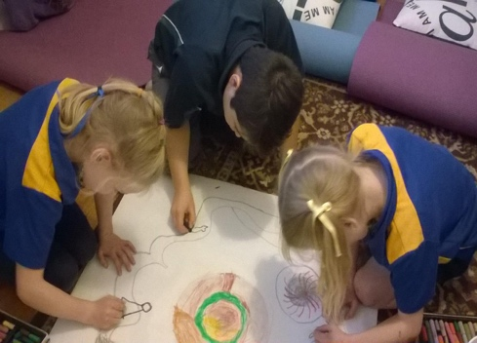
Chill Skills Facilitator Training
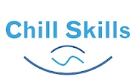
2 Day Training

Chill Skills for Kids is a 6-week program for a small group of children led by a Chill Skills for Kids trained facilitator.
Chill Skills for kid’s classes involve a range of fun activities to help kids learn how to relax, explore their imagination and learn valuable life skills.
What we do in a session
- Gentle movement
- Show the kids how to imagine their worries away
- Various styles of mindfulness & meditation to suit different age groups of children
- Therapeutic creative activities to help with self-expression
- Talk about how worry can store in the body, and how to use Chill Skills to release it
- Learn about acknowledging and interpreting emotions
- Using journals, the children learn about creating positive self-talk
Training package include
- Program manual
- Activity manual
- Program lesson plans
- Yoga cards for kids
- Admin forms
- Small singing bowl
- Cost $875

What you will learn from this training:
On completion of this training course participants will be able to:
- Identify and apply the “Chill Skills” process
- Identify and demonstrate practical skills and strategies to help children learn to relax and express themselves
- Deliver various meditation styles and mindfulness to children
- Design and conduct your own “Chills Skills” class
- Tailor “Chill Skills” classes to different age groups

When: Thursday 29th & Friday 30th January, 2026

Where: Mooroopna Education & Activity Centre, 23 Alexandra Street, Mooroopna, Vic, 3629

Times: 9.30am – 4.30pm

Morning tea, lunch & afternoon refreshments provided, please advise of any dietary requirements.

Register by emailing your completed form to:
Lisa - Tel: 0409 449 432
Email: chillskillsforkids@gmail.com

“I really liked listening to the story and music”

“I liked the Calm mantra”

“It was the best!”
“It was really fun and it calms me”

“I wish I could do it for the rest of the year”

T: 0409 449 432. E: chillskillsforkids@gmail.com W: www.chillskills.com.au

What Kid’s think of Chill Skills

